**Expected Values**

If X is a random variable, the expected value of X, E(X), is the average value of X when the random experiment is performed a HUGE number of times. The expected value of X is also called the mean of X, .

**For a Discrete Random Variable**

**Example** Toss a pair of fair coins. Define the random variable X to be the number of heads that result. If you perform this activity 1,000,000 times, the result will be 1,000,000 values of X. What is the average of these 1,000,000 values?

Since P(X=0)= , you would expect the value 0 to occur about times

Since P(X=1) = , you would expect the value 1 to occur about times.

Since P(X=2) = , you would expect the value 2 to occur about  times.

So, the sum of the 1,000,000 values will be about

0*() + 1*() + 2*().

Hence, the average of the 1,000,000 values will be about



or  = 1. If  are the possible values of X, this result has the form .

If X is a discrete random variable with values , and probability function p(x), then the expected value of X is given by

E(X) = = 

**Example** Toss a fair coin 4 times. X = number of heads. Find E(X).

**Example** A jar contains 6 red and 4 blue chips. Two chips are drawn without replacement. Let X = number of red chips that result. Find E(X).

**Example** An assembly line produces a product called a plunk. As a plunk comes off the line, it is tested for defects. Two types of defects occur. Defects of type1 cost $20 to repair and defects of type 2 cost $40 to repair. 95% of the products produced are defect free. 2% have only a type1 defect, 2% have only a type 2 defect, and 1% have defects of both types. What is the average repair cost per unit for plunks produced by this assembly line?

**For a Continuous Random Variable**

If X is a continuous random variable with pdf f(x), .

**Example** Let X have the uniform distribution on [0,2]. Then, the pdf of X is .

**Example** Let X be the RV with f(x)  .

**Functions in R**

**Creating a function**

**f<-function(variablelist) expression**

> f<-function(x) 3*x^2+sin(x)

> f(3)

[1] 27.14112

> g<-function(x,y) x*cos(y+1)

> g(3,5)

[1] 2.880511

> f<-function(x) x<2

> f(1)

[1] TRUE

> f(3)

[1] FALSE

> f<-function(x) x^2*(x<2)

> f(1)

[1] 1

> f(3)

[1] 0

> f<-function(x) x^2*(x<=2 & x>=0)

> f(-2)

[1] 0

> f(1.5)

[1] 2.25

> f(3)

[1] 0

**Create the pdf for a RV with a uniform distribution on [1,4]**

**Plotting a Function**

**plot(function,a,b)**

> f<-function(x) x^2*(x<=2 & x>=0)

> plot(f,-2,4)

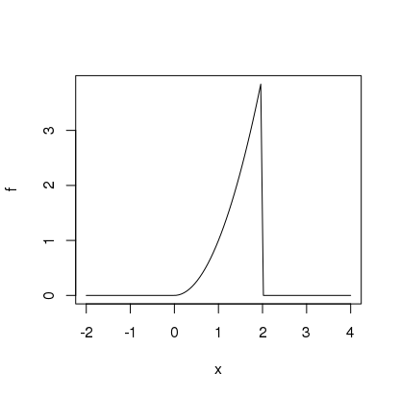

**Integrating a function**

**integrate(function,a,b)**

> f<-function(x) x^2*(x<=2 & x>=0)

> integrate(f,-2,1)

0.3333331 with absolute error < 8.4e-05

> integrate(f,0,Inf)

2.666667 with absolute error < 6.7e-05

> integrate(f,-Inf,Inf)

2.666667 with absolute error < 6.7e-05

**Example:**  Let f(x) = $\left\{\begin{matrix}e^{-x^{2}}, x≥0 \\ 0 , x<0\end{matrix}\right.$. Create f, plot f on [-3,3], and evaluate $\int_{-∞}^{∞}{f\left(x\right)dx}$.

**LOAD THE PACKAGE. mosaicCalc**

**Anti-differentiating a Function**

antiD(f(x)~x, lower.bound = a)

* f<-function(x) x^2*(x<=2 & x>=0)
* F<-antiD(f(x)~x,lower.bound=0)
* plot(F,-5,5)

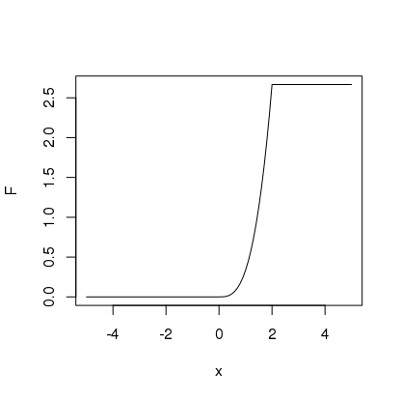

**Example:** Let X be the RV with f(x)  .

* f<-function(x) exp(-x)*(x>0)

**Verify that f is a pdf.**

> integrate(f,0,Inf)

1 with absolute error < 5.7e-05

**Find P(X≥4).**

> integrate(f,4,Inf)

0.01831563 with absolute error < 6.5e-05

**Find E(X).**

> xf<-function(x) x*f(x)

> integrate(xf,0,Inf)

1 with absolute error < 6.4e-06

**Find the cdf F**

* F<-antiD(f(x)~x,lower.bound = -1)

**Use F to compute P(2 < X < 5)**

> F(5)-F(2)

[1] 0.1285973

**Exercises 6**

1. You are invited to play the following game. You draw two chips without replacement from a jar containing 5 red, 5 blue, and 5 green chips. If both chips have the same color you win $5. If the two chips have different colors, you win $3. On average, how much will you win per game? It costs you $4 to play the game. On average, would you win money, lose money, or break even playing this game?

x $5 $3

p(x) .286 .714

On average you will win 5*.286 + 3*.714 = **$3.57**. **On average you will lose playing this game.**

1. Toss a fair coin 3 times. Let X be the number of heads produced. Find the probability function for X and use it to find the average number of heads produced when the coin is tossed 3 times.

**x 0 1 2 3**

**p(x) 1/8 3/8 3/8 1/8**

E(X) = (0+3+6+3)/8 = **3/2 = 1.5**.

1. Repeat (2) above under the assumption that the coin is biased and has a 1/4 chance of producing a head.

**x 0 1 2 3**

**p(x) 27/64 27/64 9/64 1/64**

E(X) = (27+18+3)64 = 48/64 = **¾ = .75**.

4 a. Let f(x) = $\left\{\begin{matrix}2e^{-2x}, x≥0 \\ 0, x<0\end{matrix}\right.$. Create this function in R and use R to integrate it on [0, $∞).$**Note that ex is expressed in R as exp(x).** Does it follow that f(x) is a probability density function?

**> f<-function(x)2*exp(-2*x)*(x>=0)**

**> integrate(f,0,Inf)**

**1 with absolute error < 5e-07**

b. Use R to compute P(-1≤X≤3).

**> integrate(f,-1,3)**

**0.9975212 with absolute error < 1.1e-14**

c. Use R to compute the cumulative distribution function F(x) =  and use F to compute the answer to P(3≤X≤10)

**> F<-antiD(f(x)~x, lower.bound = 0)**

**> F(10)-F(3)**

**[1] 0.00247875**

d. Use R to compute the mean of the random variable for which f(x) is the pdf.

**> xf<-function(x) x*f(x)**

**> integrate(xf,0,Inf)**

**0.5 with absolute error < 8.6e-06**

5. Let . Do the following by hand, without using R.

1. For what value of C is f a probability density function?
2. If X is the associated random variable, what is E(X)?
3. Find P(X > 2).